Study relation between push and time and length of string to perform operation

To do this study Perl was used. Gnuplot was necessary to generate graphs, harts,...

Data calculated:
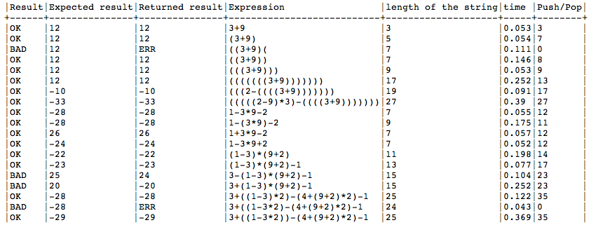
Board that shows data taken for one session

Three columns will be the main subject about this paper.
Length of the string (we don't want to know the content of it. Time to perform this operation (one expression can contain different operations). The push and pop that's how the calculus is done for this study.

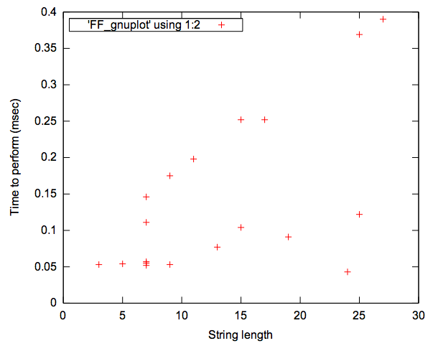
Time to perform ms

We can see that for one length there are different times. Let's check push and pop to see what's under the tongue...

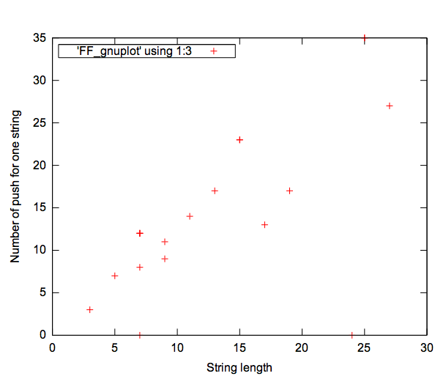
Number of push

For the same amount of character we notice that the number of push and pop varying.

String length of 7 characters if interesting for instance. There are 5 sets. A difference in time execution is noticeable. Both exepression have 12 pushes.
Need to check in te algorithm the importance of execution of operation (order in if elsif else endif).

